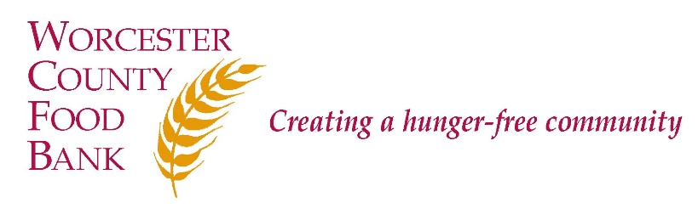

Worcester County Food Bank
Advocacy Associate -SNAP Outreach
DESCRIPTION:
Worcester County Food Bank (WCFB) believes that food is a fundamental right of all people and that hunger is an issue of social justice. WCFB’s mission is to engage, educate, and lead Worcester County in creating a hunger-free community. To that end, WCFB annually collects over 7 million pounds of perishable and non-perishable food and distributes it through a network of Partner Agencies, including food pantries and community meal programs, trains Partner Agencies in food safety, and advocates for systemic and sustainable solutions to support children, families, and senior citizens in being more food secure and healthy. WCFB is deemed to provide essential services to the community in time of emergencies.

Under the supervision of the Director of Advocacy (temporarily Agency Relations Manager), the Advocacy Associate will perform SNAP outreach to low-income communities throughout Worcester County to promote awareness of and increase access to SNAP benefits. The Associate will provide direct assistance to clients applying for SNAP benefits and will oversee between 8 to 12 SNAP participant cases each month and follow up with participants regarding completion of application, pending documents, interview appointments, recertifications, and case outcome. This position has been changed due to the Covid-19 Pandemic, for the time being all outreach and participant cases will be conducted via phone or other technology to ensure physical distancing. WCFB will continue to follow CDC guidance, and in the future this position may be expected to travel to WCFB Partner Agencies to provide in-person assistance.

This position is designated essential to WCFB’s operations.

RESPONSIBILITIES:
- Become knowledgeable of the SNAP Program regulations, eligibility requirements, and application process
- Conduct direct service outreach to food-insecure families, individuals, seniors, people with disabilities, and other diverse populations
- Assist food-insecure households with the SNAP application and ensure completion
- Serve as liaison between applicant and the MA Department of Transitional Assistance (DTA) for follow-up and communication as needed
- Advocate on behalf of applicant if obstacles occur, or refer to WCFB partner at Community Legal Aid
- Update tracking systems in Microsoft Excel
- Attend weekly meeting to discuss work with Supervisor

QUALIFICATIONS:
- Commitment to WCFB’s mission
- Bilingual skills in prominent languages spoken locally highly desired, including Spanish, Vietnamese, Portuguese
- A strong sense of and respect for confidentiality involving both Partner Agency guests and employees
- Passion for hunger relief, social justice, and interest in public benefits assistance or social work
- Must have excellent customer service and communication skills, and the ability to establish rapport
- A valid driver’s license and reliable transportation, having a car is preferable as travel is expected to be a major component of this position in the future depending on CDC guidance
- Ability to work and communicate in a variety of settings with culturally diverse families and communities with the ability to be culturally sensitive and appropriate
- Ability to work independently and collaboratively
- Strong computer proficiency in Windows, Excel, Microsoft Word, internet and e-mail applications
- All applicants will be subject to a full background check including a CORI
- WCFB is a Equal Opportunity Employer. We strongly encourage people of color, women, LGBTQIA individuals, people with disabilities, and people who have experienced poverty to apply.

Pay Scale: $15.00 - $18.00 per hour Status: Non-exempt – Part time

How to Apply: A formal cover letter is required for consideration.

- E-mail jobs@foodbank.org (subject line: “Advocacy Associate -SNAP Outreach”); or
- Mail cover letter and résumé to Worcester County Food Bank, Attn: Lara Greene, 474 Boston Turnpike, Shrewsbury, MA 01545.

