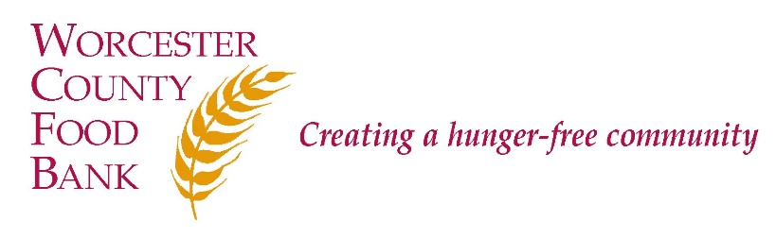

Worcester County Food Bank

DEVELOPMENT MANAGER
Worcester County Food Bank (WCFB) believes that food is a basic human right and that hunger is an issue of social justice. WCFB’s mission is to engage, educate, and lead Worcester County in creating a hunger-free community. To that end, WCFB collects perishable and non-perishable food and distributes it through a network of Partner Agencies, including food pantries and community meal programs; trains Partner Agencies in food safety; and advocates for systemic and sustainable solutions to the problem of hunger. WCFB is deemed to provide essential services to the community in times of emergencies.

DESCRIPTION:
The Development Manager is works closely with team members to raise awareness and funds in support of WCFB’s mission. The Manager informs, develops, and executes upon WCFB’s communications and development strategies, maintains a portfolio of donors and donor prospects and helps to cultivate corporate and community support for WCFB. This is a full-time, exempt (salaried) position that reports to the Director of Communications and Development.

This position is designated essential to WCFB’s operations.

RESPONSIBILITIES:

Individual and Corporate/Community Giving
- Researches and identifies strategies to deepen relationships with Individual and Corporate/Community supports; builds strong, lasting relationships with these donors on behalf of WCFB.
- Maintains a portfolio of individual and corporate/community donors; provides support to the Director of Communications and Development and CEO to manage their portfolios.
- Routinely interfaces with WCFB supporters online, by phone, and in-person and models donor-centered communication in each interaction.
- Solicits support from the business community for the 96.1 SRS Feed Worcester County Food Drive.

- With guidance from Director of Communications and Development, represents WCFB at various corporate and community events and meetings with a development component, coordinates visits and leads tours of WCFB for corporate and community stakeholders.

Event/Cause Marketing
- Keeps team members informed of current local and national business promotions, in particular, corporate and cause marketing campaigns organized by Feeding America.
- For register campaigns, ensures appropriate third-party paperwork is complete and returned in a timely manner (ie: obtaining sign-off of CEO, through the Director of Communications & Development, on memorandums of understanding, etc.); obtains and enters copies in the donor’s record.
- With direction from Director of Communications & Development, responds to inquiries from community members including requests for WCFB staff to appear or speak at third-party events; provides guidance and marketing materials to community members seeking support with third-party fundraisers.

Gift Entry, Processing, Acknowledgment and Reporting
- Manages gift acknowledgment process including: Developing and documenting written strategies and procedures around process in concert with the Director of Communications & Development; drafting acknowledgment templates; working with team members and volunteers to ensure acknowledgments are timely sent and received; preparing Donor Perfect reports by request of donors, team member, or CEO; and - with Director of Communications & Development – identifying and implementing additional opportunities for donor recognition, stewardship, and appreciation.
- Oversees staff responsible for daily gift processing and acknowledgment.
- Pulls and analyzes donor reports from donor database, Tableau, and other sources in order to measure effectiveness of communication and development strategies; helps to generate monthly, quarterly and yearly reports (ie: QPR) in concert with Director of Communications & Development.
- Works closely with and serves as back-up to Development Coordinator, provides at least monthly assistance with entering fits to maintain base of knowledge, closely observes policies.
- Provides training for development staff in use of and procedures related to donor database, gift processing, and acknowledgment.

Management
- Works collaboratively with team members to set and achieve goals for fund development.
- Participates actively in 1:1’s and team meetings and elevates concern, questions and ideas to Director of Communications & Development as appropriate.
- Supervises Development Coordinator, temporary staff, staff on temporary assignment, and office volunteers performing development functions; responsible for working with supervisees to set goals, including SMART goals, monitor their progress and hold them accountable for such.

Communication
- As needed, provides development-centric contributions to annual Impact Report and print newsletters; may help generate content for monthly e-newsletter.
- With team members, informs and executes on direct mail plan, works closely with Director of Communications & Development and vendor to provide data that informs how well direct mail is performing as against goals for each communication.
- Manages donor mailing lists and communications preferences; generates lists for communication with portfolio donor and as requested by direct mail vendor and Feeding America.

Others

- Performs other duties as assigned by Director of Communications & Development or COO.

QUALIFICATIONS:

- Commitment to WCFB’s mission to end hunger, understanding of and commitment to equity and social justice.
- Bachelor’s Degree plus at least 3-5 years’ relevant experience
- Commitment to a flexible work schedule to meet the organizational needs of WCFB.
- Exercises good judgement and safeguards donor confidentiality and, with team members, establishes and adheres to clear and consistent boundaries.
- Highly motivated and organized: Able to work independently and as part of a team, establish priorities, develop timetables, multi-task, and engage each donor with sincerity and enthusiasm.
- Exemplary communication skills – verbally and in writing.
- Comfortable interfacing with a variety of constituents: Staff, board members, community and business leaders, volunteers, etc.
- Proficient in use of Microsoft Office suite.
- Experience in use of donor databases (Donor Perfect prefer).
- WCFB is an Equal Opportunity Employer. We strongly encourage people of color, women, LGBTQ individuals, people with disabilities, and people who have experienced poverty to apply.

Current Salary Range: $54,080 – 74,880 per year. Status: Full Time – Exempt

How to Apply: A formal cover letter is required for consideration.

- E-mail jobs@foodbank.org (subject line: “Development Manager”); or
- Mail cover letter and résumé to Worcester County Food Bank, Attn: Lara Greene, 474 Boston Turnpike, Shrewsbury, MA 01545.

WCFB is an Equal Employment Opportunity (EEO) employer and welcomes all qualified applicants. Applicants will receive fair and impartial consideration without regard to race, sex, color, national origin, age, disability, veteran status, genetic data, or religion or other legally protected status.

