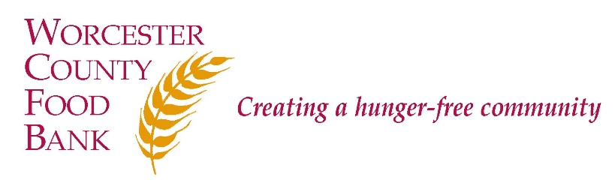

Worcester County Food Bank
COMMUNICATIONS MANAGER

Worcester County Food Bank (WCFB) believes that healthy food is a fundamental right of all people and that hunger is an issue of social justice. WCFB’s mission is to engage, educate, and lead Worcester County in creating a hunger-free community. To that end, WCFB annually collects donations of perishable and non-perishable food and distributes it through a network of Partner Agencies, including food pantries and community meal programs; trains Partner Agencies in food safety; and advocates for systemic and sustainable solutions to support children, families, and seniors in being more food secure and healthy. WCFB is deemed to provide essential services to the community in times of emergencies.

POSITION SUMMARY:

The Communications Manager is a full-time, exempt (salaried) position that reports to the Director of Communications & Development. The position is responsible for supporting a multi-faceted communications strategy in support of the organization. The position works across departments to provide day-to-day support as well as strategic leadership on multiple fronts, including to: ensure consistent messaging and branding, create a strong web and social media presence, and develop engaging printed materials.

This position is designated essential to WCFB’s operations.

RESPONSIBILITIES:
- Messaging and Branding
  - Maintain and regularly update WCFB’s overall messaging and branding strategies, ensuring that colleagues across the Food Bank are aware and involved in executing a consistent voice and message.
  - Maintain and update WCFB’s Branding Guide, including graphics standards and style guide.
  - Maintain WCFB’s communications calendars.
  - Coordinate strategies for telling personal stories that highlight the positive impact of WCFB’s work across communication channels.
- Website, Social Media and E-News
  - Maintain WCFB’s website content and photos, ensuring that website content is engaging, informative and up-to-date.
  - Create, update, execute, and continuously evaluate social media plan, focusing on engaging a variety of audiences ranging from community members, volunteers, donors, advocates, and elected officials.
  - Create, update, and execute an email marketing strategy for the organization, ensuring consistency across channels and audiences.
  - Introduce strategies to grow WCFB’s social media and email followers.
  - Collect, take, store and use WCFB photos in an organized and accessible manner.
- Printed Materials and Publications
  - Coordinate content creation, design and printing for annual publications, such as the infographic, impact report, advocacy priorities, printed newsletters, etc.
  - Design and produce flyers, handouts, and informational materials for a variety of audiences, including donors, legislators, advocates, and Partner Agencies using Adobe Creative Suite.
  - Work with colleagues across departments to create content, manage contributors, and keep projects on schedule.
  - Coordinate mailings as needed.
- Press
  - Work with colleagues to identify and pitch potential media opportunities.
  - Lead media outreach efforts and cultivate relationships with individual media representatives.
  - Maintain archive of WCFB press mentions.
- Other
  - Attend events on behalf of WCFB as needed.
  - Manage vendors as needed.
  - Additional responsibilities as assigned.
QUALIFICATIONS:
- Bachelor's Degree or relevant experience required, ideally with at least 3 years of experience in a communications role.
- Strong interpersonal skills, including the ability to work collaboratively as part of a team as well as individually.
- Strong ability to take initiative, proactively plan and manage workload, engage in creative problem solving, and work independently.
- Ability to work across departments, as well as a sense of how to seek out and develop new content to contribute to messaging, branding, and publications.
- Understanding of and commitment to social justice and ending hunger.
- Understanding of advocacy and the importance of civic engagement.
- Outstanding writing and communication skills, with strong attention to detail.
- Experience in project management with multiple stakeholders.
- Experience designing publications and web graphics using Adobe Creative Suite.
- Demonstrated ability to utilize and manage social media platforms for an organization or business purpose.
- Experience with Word Press, Adobe Creative Suite, Microsoft Office suite, as well as ability to learn and use new technologies. Experience with Constant Contact preferred but not required.
- Enthusiasm and a positive attitude.
- Willingness to occasionally travel locally and regionally for meetings and as needed for national conferences.
- WCFB is an Equal Opportunity Employer. We strongly encourage people of color, women, LGBTQ individuals, people with disabilities, and people who have experienced poverty to apply.

Current Salary Range: $54,080 – 74,880 per year. Status: Full Time – Exempt

Worcester County Food Bank
COMMUNICATIONS MANAGER

How to Apply: A formal cover letter is required for consideration.

- E-mail jobs@foodbank.org (subject line: “Communications Manager”); or
- Mail cover letter and résumé to Worcester County Food Bank, Attn: Lara Greene, 474 Boston Turnpike, Shrewsbury, MA 01545.

WCFB is an Equal Employment Opportunity (EEO) employer and welcomes all qualified applicants. Applicants will receive fair and impartial consideration without regard to race, sex, color, national origin, age, disability, veteran status, genetic data, or religion or other legally protected status.

