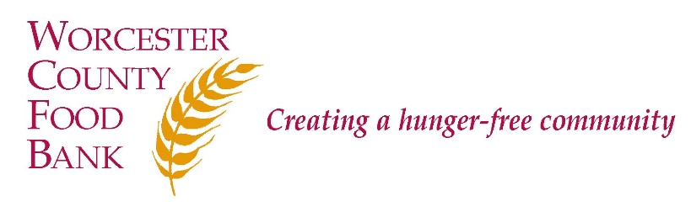

DIRECTOR OF ADVOCACY

Summary of Responsibilities

Worcester County Food Bank (WCFB) believes that food is a fundamental right of all people and that hunger is an issue of social justice. The Director of Advocacy manages a multi-faceted advocacy program in support of WCFB’s mission. The Director provides strategic leadership, as well as day-to-day support, for all aspects of WCFB’s advocacy program, including collaborating with various community stakeholders to drive successful action, advocating for anti-hunger legislative initiatives, and empowering individuals and groups at the local and state levels to improve community health and well-being through education, research, and activism. This senior leadership position also manages Advocacy staff including: SNAP Outreach Interns, Advocacy Coordinator, and Worcester Food Policy Council Manager.

WCFB is deemed to provide essential services to the community in times of emergencies and this position is designated essential to WCFB’s operations..

Qualifications

The ideal candidate will have:
  - Leadership ability and professional communication skills;
  - Experience in supervising and managing staff;
  - Strong interpersonal skills, including the ability to work collaboratively as part of a team.
  - Strong attention to detail;
  - Strong computer and technical skills;
  - Ability to digest technical documents (i.e. legislation, budgets); and
  - Flexibility and ability to adapt quickly to changing circumstances and priorities.
Plus:
- Bachelor's Degree required (Master’s Degree preferred) along with a minimum of 5 years of experience in advocacy and/or government relations in a nonprofit organization;
- Commitment to WCFB’s mission and understanding of food justice and food systems work;
- Commitment to diversity, equity, and inclusion;
- In-depth knowledge of state and federal legislative processes and knowledge of developing and participating in effective campaigns;
- Knowledge of Supplemental Nutrition Assistance Program (SNAP) and experience with outreach and application assistance;
- Commitment to a flexible work schedule to meet the organizational needs of WCFB and the Advocacy Department including attendance at annual food and fund drive signature event and WCFB board meetings;
- Willingness to travel locally, regionally, and nationally as needed for meetings, conferences, presentations, etc.

Current Salary Level: $34.00 - $44.00 Status: Exempt Reports to: Chief Executive Officer

How to Apply:

A formal Cover Letter is Required
- Online at indeed.com;
- E-mail jobs@foodbank.org (subject line: “Director of Advocacy”); or
- Mail cover letter and résumé to Worcester County Food Bank, Attn: Lara Greene, 474 Boston Turnpike, Shrewsbury, MA 01545.

WCFB is an Equal Employment Opportunity (EEO) employer and welcomes all qualified applicants. Applicants will receive fair and impartial consideration without regard to race, sex, color, national origin, age, disability, veteran status, genetic data, or religion or other legally protected status.

