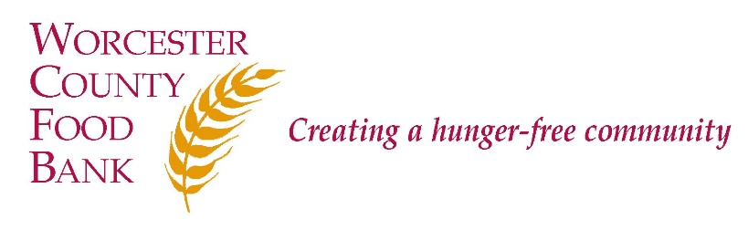
Worcester County Food Bank
Job Description
TITLE: Temporary Volunteer Associate
STATUS: 40 Hours, Non-Exempt, Temporary

REPORTS TO: Agency Relations Manager

DESCRIPTION:
Worcester County Food Bank (WCFB) believes that food is a fundamental right of all people and that hunger is an issue of social justice. WCFB’s mission is to engage, educate, and lead Worcester County in creating a hunger-free community. To that end, WCFB collects perishable and non-perishable food and distributes it through a network of Partner Agencies, including food pantries and community meal programs, trains Partner Agencies in food safety, and advocates for systemic and sustainable solutions to support children, families, and senior citizens in being more food secure and healthy.

The Volunteer Engagement Associate is a full-time, non-exempt (hourly), temporary position that reports to the Agency Relations Manager. This position works closely with the WCFB Operations department to ensure safe Food Sorting practices within the WCFB Warehouse. In the case of a local, state, or federal emergency, WCFB is an essential organization and so this position is essential and will be called upon to perform essential duties in order to carry out the mission of WCFB. This position is 100% on-site at WCFB.

Essential RESPONSIBILITIES:
Volunteer Coordination
- Be the main point of contact for all WCFB Volunteers, answering questions and queries from current, former, and interested new volunteers.
- Coordinate volunteer schedules to ensure safety within the Warehouse sorting area and to maximize volunteer time, abilities, and strengths.
- Oversee and ensure safe social distancing for Volunteers while on-site at WCFB
- Fully learn and understand Food Sorting procedures in order to be able to train and respond to questions regarding the procedures
- Oversee Food Sorting procedures, including pre-sort, final-sort, and quality control so that WCFB is distributing food product that is high quality in an efficient manner
- Liaise with appropriate staff to ensure quality standards for work performed by volunteers.
- Collect and maintain volunteer data and report on volunteer data as required by various departments.
- Maintain Volunteer Center for cleanliness to be used on an individual basis by volunteers.
Other Essential Work
- Provide customer service in response to incoming phone calls and visitors; transfer calls and refer visitors according to the WCFB Referral Guide.
- When necessary, complete Food Sorting activity to increase Partner Agency access to high-quality food product
- Respond to requests for Food Assistance, in person or via phone or email, to ensure people throughout Worcester County have access to immediate food needs.

Other Work
- Familiarize self with WCFB fast facts and figures, as well as the ongoing WCFB response to Covid-19 to tell this information to volunteers.
- Other duties as assigned.

QUALIFICATIONS:
- Demonstrated 1-2 years’ experience in volunteer coordination and/or management.
- Friendly, professional, and highly organized, with demonstrated outstanding customer services skills.
- Strong interpersonal skills, including the ability to work collaboratively as part of a team as well as individually.
- Positive, can-do attitude.
- Willingness to learn the WCFB approach to volunteers, food assistance, and other essential duties.
- Ability to keep good electronic records of work using Microsoft Outlook and Microsoft Office and other applications.
- Solid knowledge of various computer applications including but not limited to Microsoft Office Suite and database systems. Experience with or willingness to learn Donor Perfect Database.
- Food Safety background desirable, including but not limited to Servsafe certification desired but not required. Servsafe certification included as part of on the job training.
- Bilingual/bicultural a plus, but not required.

Pay Range: $15.00 to $18.00 per hour Status: Non-Exempt
How to Apply:
1) Submit Cover Letter and Resume online at Indeed.com
2) E-mail Cover Letter and Resume: jobs@foodbank.org (subject line: “Temp Volunteer Associate”); or
3) Mail cover letter and résumé to Worcester County Food Bank, Attn: Lara Greene, 474 Boston Turnpike, Shrewsbury, MA 01545.
WCFB is an Equal Employment Opportunity (EEO) employer and welcomes all qualified applicants. Applicants will receive fair and impartial consideration without regard to race, sex, color, national origin, age, disability, veteran status, genetic data, or religion or other legally protected status.

