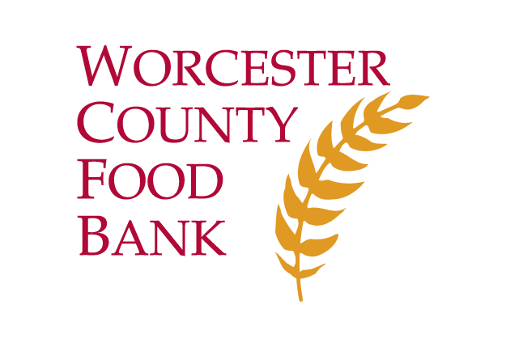
2019 MA Policy Agenda
Fund HIP at $8.5 Million - This amount will enable year-round operation of the Healthy Incentives Program (HIP) and the onboarding of several new farms to meet demand in underserved areas. HIP supports farmers, promotes healthy food access, and boosts local economies by matching SNAP dollars spent at participating farmers and mobile markets, farm stands and CSAs throughout the Commonwealth.
FY 2020 Budget
UPDATE: Currently approved at $6.5 Million.

Fund MEFAP at $20 Million - The Massachusetts Emergency Food Assistance Program (MEFAP) provides quality, nutrient-rich foods and locally grown fresh produce to MA residents in times of hardship through the four Food Banks and their network of 845 food pantries, community meal programs, and shelters.
Legislation

UPDATE: Currently approved at $20 Million.

Breakfast After the Bell (DiDomenico S.267/Vega H.591) - This legislation would ensure that all MA schools where 60% or more students qualify for free or reduced meals serve breakfast to all students after the school day begins, so our children and youth can be free from hunger while they learn. Breakfast After the Bell programming, run with federal reimbursements, improves breakfast participation, academic performance and school bottom lines. Last session, the bill received unanimous support in the MA Senate.

Promote Student Nutrition (Creem S.256/Vargas H.585) - This legislation would ensure students are not shamed for meal debt and that any payment issues are addressed directly with parents. It would also support schools in ensuring all eligible families are being served through free school meal programs.

Close the “SNAP Gap” (DiDomenico S.678/Livingstone H.1173) - This legislation would create a common application for MassHealth and SNAP. This would improve administrative efficiency and increase food security for more than 700,000 people who use MassHealth and qualify for SNAP but are not currently enrolled.

Legislate HIP (Gobi S.48/Mark H.145) - This legislation would establish the Healthy Incentives Program (HIP) in statute. This would help ensure that this amazing SNAP-matching program continues to support farmers and those experiencing food insecurity, while providing economic, public health, and environmental benefits for the Commonwealth.

Reduce Food Waste (Kennedy S.492/Kane H.811) - This legislation would implore DPH to standardize the date labeling of food to reduce confusion and unnecessary food waste; currently, there are no food industry-wide standards to date labeling.

Encourage Food Donations (Kennedy S.962/Kane H.1475) - This legislation ensures adequate liability protections for persons and companies donating food to food banks, pantries, and community meal programs.
Contact: Maggie Cawley, Advocacy Coordinator, mcawley@foodbank.org
(508) 842-3663 ext. 249 www.foodbank.org
474 Boston Turnpike ~ Shrewsbury, Massachusetts 01545-3948

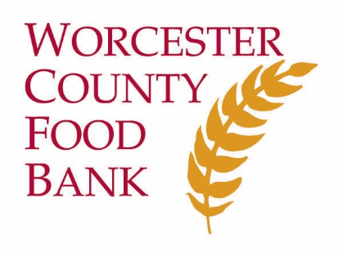
Speak Up to End Hunger

WCFB believes that food is a basic human right and that hunger is a social justice issue. We advocate with our partners, communities, and elected officials to create long term solutions to the root causes of hunger.

We believe that to end hunger we must:
- Raise Wages & Increase Economic Opportunity
- Support a Healthy & Equitable Food System
- Support & Protect State and Federal Funding for Food Assistance Programs

Our Advocacy Partners

Local
Worcester Food Policy Council
Worcester Community Labor Coalition
Community Legal Aid/Central West Justice Center

Statewide
Massachusetts Law Reform Institute
Massachusetts Public Health Association
Project Bread
MA Food System Collaborative
Food Bank Coalition of MA
Rise and Shine Coalition

Regional
Food Solutions New England

National
Feeding America
Food Research and Action Center
MAZON: A Jewish Response to Hunger
Share Our Strength
Your Voice Matters!
- Did you know that an elected official takes notice of an issue after just three phone calls?
- Did you know that a personalized email or letter from a constituent really makes a difference to a policy maker?
- Did you know that just a few comments on social media can get a legislator’s attention?

Take Action!
- Sign up to receive our action alerts at foodbank.org/speak-up-about-hunger/sign-up-for-action-alerts.
- Contact your local, state and federal elected officials to ask them to support programs and policies that enable people to live hunger-free and healthy. Not sure who your elected officials are? Visit www.wheredoivotema.com.
- Connect with us and your elected officials on social media!
- Share Your Story. Have you or someone you love experienced the hardship of not having enough food? You can help our elected officials understand. Consider sharing your story at foodbank.org/speak-up-about-hunger/get-involved-in-advocacy/share-your-story.

www.foodbank.org
/WorcesterCountyFoodBank
@WorcesterCtyFoodBank

