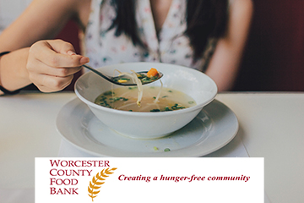
RECOMMENDED
FOOD DRIVE ITEMS

While we appreciate all support, WCFB makes every effort to increase the amount of healthy foods provided to our neighbors in need.

- Jelly - applesauce - canned & dried fruits
- Whole-wheat pasta, brown, & wild rice
- Cooking oil (vegetable & olive)
- Low sodium soup, stew, chili
- Low-sodium chicken or beef broth
- Low-sodium canned vegetables
- Healthy snacks (nuts, granola, etc.)
- 100% fruit & vegetable juices
- Gluten-free foods
- Canned pasta sauce (NO glass jars)
- Please NO glass (including baby food)
- Please NO perishable items

